HDFCMF Website
SOP : : Disclosure Scheme Financials

Steps to follow :

Step 1 : Login into CMS ->

1.Click on
Content 2. Add content 3. Search Disclosure: Scheme Financials

Create Disclosure: SCHEME FINANCIALS Page should open :Refer the images below:

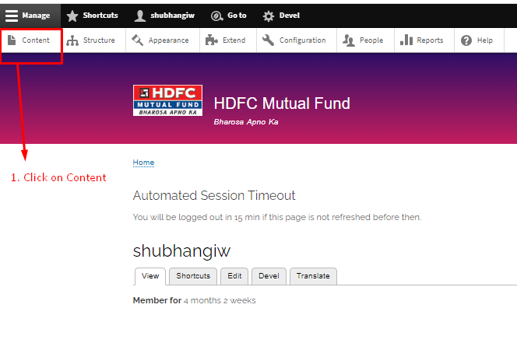

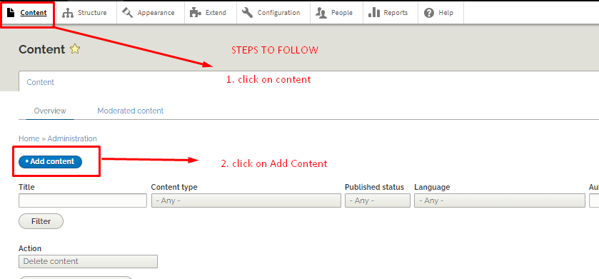
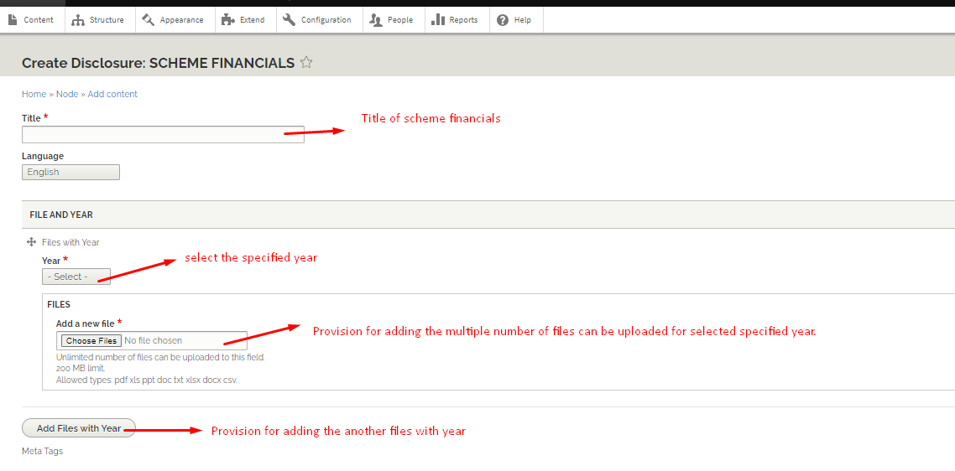
3. Search Disclosure : Scheme Financials -> click on Disclosure : Scheme Financials



